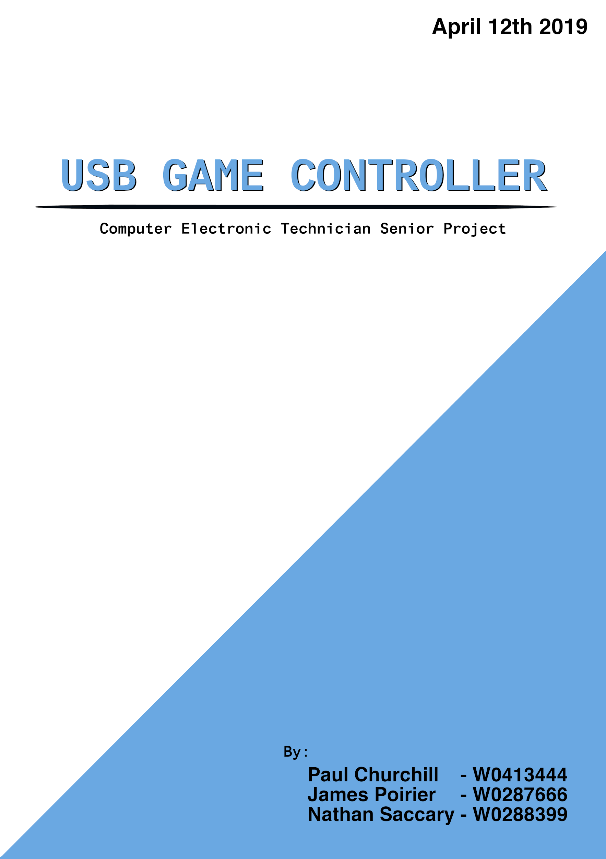

# Summary

Our project was to create a high-quality USB controller. We came up with the idea by merging James’ idea of creating a game controller with Paul’s idea of creating a keyboard. James’ idea for a game controller, thought up during the first year would have been similar to the Portable Game Controller project; the idea that became his final project for the embedded controller class. Paul is a mechanical keyboard enthusiast and planned on building one up from scratch. When talking to each other the idea arose that “What if a controller used mechanical key switches”. We expanded this idea to what our goal is now with the help of Nathan who proposed that we also focused on the body, making sure it feels nice to hold.

Our end product did not meet our goal, it is however not too far off. The end product of this project would be considered our 2nd to last prototype, the final prototype being a test fitting of all the finalized parts.

Throughout this project we had to some decisions. With time as a constant the choices were usually to sacrifice quality or sacrifice features. With our goal in mind *to create a high-quality controller* features were what got sacrificed to the great time gods. The key decision that opposes this idea would be the 3d printed chassis. Because of the incredible difficulty of creating a model where every inch consisted of a custom curve, we couldn’t save any time other than using a simpler model.

In conclusion, we have a prototype that is in line with our goal, and quite close to reaching our goal. We are very happy with the result and plan to finish our goal.

# 

# Table of contents

Summary

Table of contents

Introduction (with our goal as the final product)

Goal

Our team:

Importance:

Applications:

Limitations:

Main body

The Beginning:

James

Paul

Nathan

Clay Prototype:

James

Nathan

Paul

3D Printed Prototype:

James

Paul

Nathan

Remaining Work

James

Paul

Nathan

Conclusions

Features:

Applications:

Limitations:

Learned:

The Future:

Tech Showcase:

References

Appendices

Component Specifications:

# Introduction (with our goal as the final product)

## Goal

Our goal is to create a USB game controller for PC. This game controller has feel and build quality as it's number one priority. Being sturdy, tough, comfortable grip, balanced weighting, nice texture, satisfying and low-delay key presses, key mapping. An overall high-quality product.

We want to design the controller in a way that will allow it to be produced. This means having Schematic and Gerber files that could be used to manufacture a PCB, having a detailed 3D model that can be used on CNC machines.

To achieve comfort, we plan on carefully sculpting a handle and body that will hug the hand, and provide a shape that distributes the weight. We want to find a shape that gives the best feel for the most amount of grip styles and hand sizes.

To achieve sturdiness and texture we plan on carving a 3D model based on the sculpture out of wood and sanding it to perfection. The wooden chassis should only have just enough room inside to fit the components, making is feel solid.

To achieve satisfying key presses, we plan to do something no commercial game controller has done before and use Mechanical key switches (designed for keyboards) they offer a better feel then the typical rubber dome button. We plan on customizing the keycaps for easier glide (sliding fingers between buttons) and reducing height.

To achieve key mapping, we plan on having a companion software written in C99 that can detected the attached controller and offer a (graphical) user interface that can change what input is sent when a button is pushed.

We also plan on having a rumble motor for providing feedback

## Our team:

James - scrum master, programmer

Paul - Circuitry, Soldering, PCB design

Nathan - 3D modeling

As a part of being the scrum master James managed the GitHub which contained a Kanban chart, a wiki to hold our scrum minutes, and code.

<https://github.com/srjamesjr/CoNtrOleR>

## Importance:

The reason we wanted to create this controller is that we felt a lack of quality in the average PC controller and each had ideas on ways to improve. We would want this to be important to anyone who uses a USB controller as we hope to improve or keep the quality in all aspects of a controller.

## Applications:

Our goal controller will have the same outputs as a standard controller making its use case anywhere a USB controller could be used. Our application and intent was for video games but that is not a limitation.

With the ability to remap the outputs of our controller to keyboard, mouse or serial data the uses for it become much greater. It could then be used for any application that needed user input through USB.

## Limitations:

Our goal controller will still have the inherent limitation of controllers; A controller cannot have the amount of buttons a keyboard has, and it cannot have the pixel precision a mouse would have.

As a commercial product would have a high price point because of the amount of work and higher quality components we’ve put into it. This would make the controller less accessible to the average person

# Main body

## The Beginning:

### James

Before starting this project, James had done some research on microcontroller that could be used as a HID. all of the results where about Arduino (Leonardo/pro mini/ pro micro) or Teensy.[1][2][3][5]. Around this time, he was talking to Paul about working as a group for the final CET project. Paul was looking into creating a keyboard. James did more research and found projects with the teensy that where entire keyboard [8], he looked into it further and was very impressed with the projects built with it[4][7], and the specs of the mk20dx256 chip it uses(72Mhz and overclockable). [9] shortly after we combined our ideas of a mechanical keyboard and a controller, and combined Nathan to create what is now our goal

When the time came to start on the project James was a little bit lost because he was tasked with coding but had no microcontroller. The first few days he spent time reading all the examples and information of their website[9], preparing github (the repository, kanban and wiki) and created code that would hopefully run, but there was currently no way to test.

When the coffee table emulator was tore down, James borrowed the Arduino Leonardo used in it. He knew it wouldn’t be what we used as the final product, but getting it to work as a analog controller should make doing the same thing, on a different chip much easier (it did). He found a library after not much searching because it was pretty popular[11][12] The first thing i did was check the licensing, even though the Leonardo would not be used as our final product i wanted to make sure that option would be open(it is GNU)[13].

With the library, coding wasn’t too hard. For buttons you just read pins that toggled the state of the controller button you wanted. We were using very high-quality key switches so debouncing wasn’t an issue. James didn’t notice at the time, but he had turned on the internal pullup resistors but was also wiring pulldown resistors. Pulldown resistors in a TTL circuit consume more current.

On the clay model James focused on perfecting curves, making sure that there was enough room there is enough room to to put your fingers comfortably while holding in any grip style. James also came up with the idea to have the handle curve in a way that the Palm side of the handle would be thicker, then much like your fingers it gets thinner going to the other side. Mimicking the way that fingers grip give the handles a very nice feel when holding them.

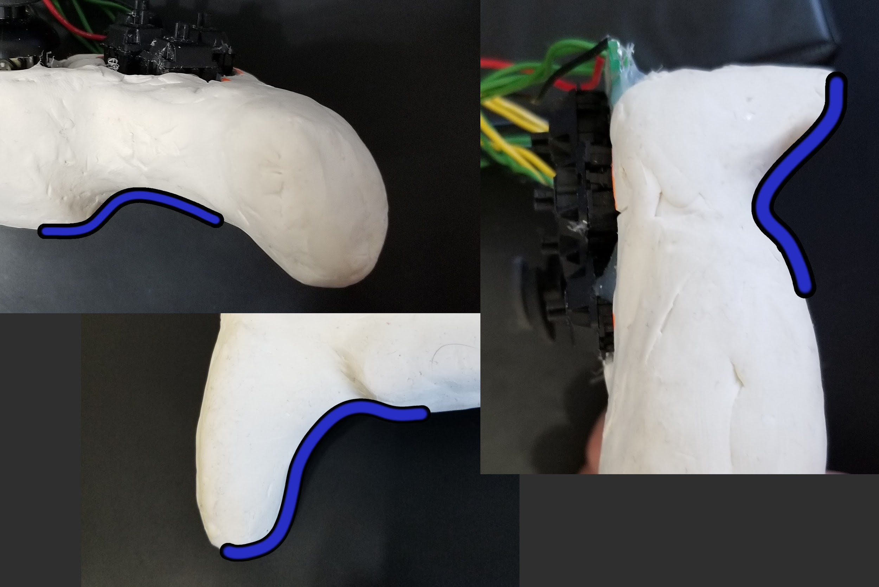

Fig. Clay model curves

### Paul

The first day or two was mostly about planning the controller layout. We had existing controllers such as the Dualshock 4 and Xbox One controllers as a reference for size and layout. The most important factor when deciding the layout of the controller is the size of mechanical key switches. Some searching for a datasheet found that Cherry MX switches are 15.6 square millimeters[26], significantly larger than buttons seen on the vast majority of other controllers. To keep the horizontal size from being too large, while also making it easy to hit all the necessary buttons a diamond shape layout was decided.

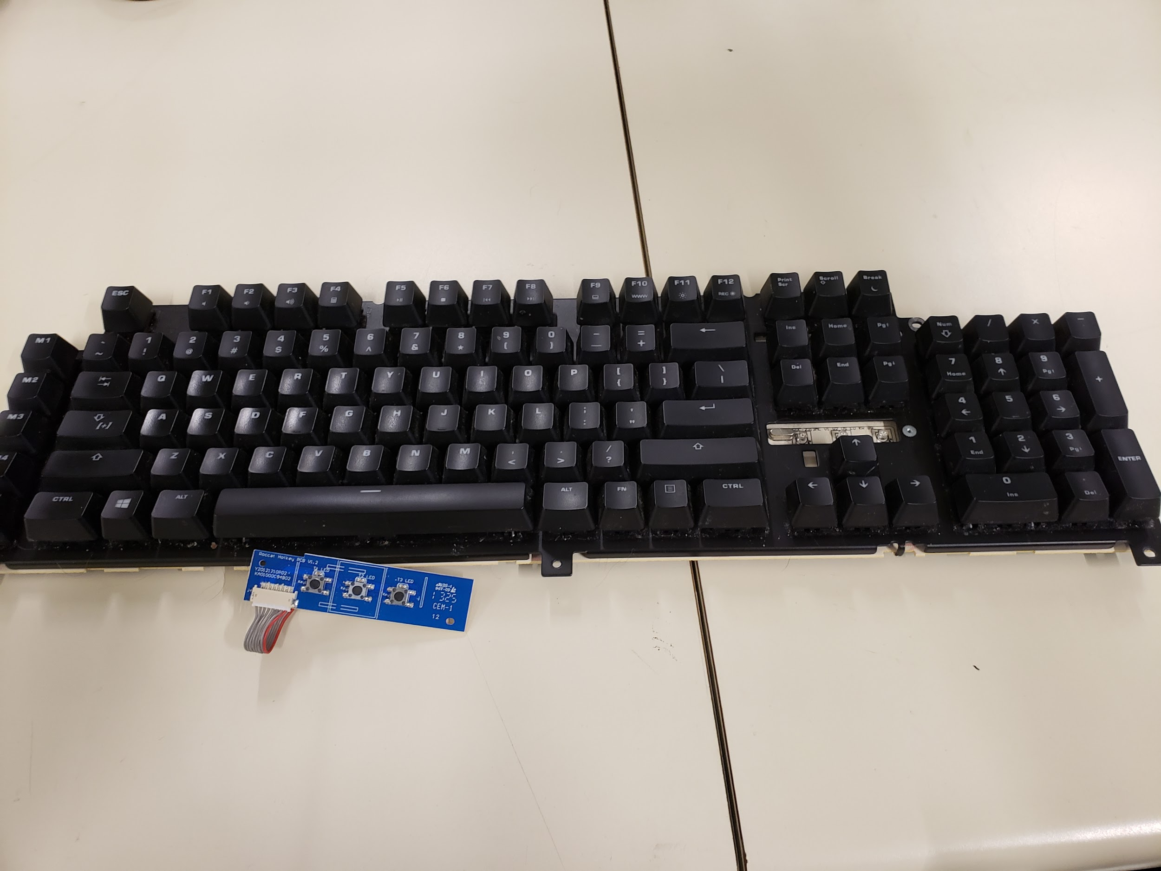

Fig. Mechanical Keyboard

Another decision point was what kind of Cherry switch we wanted to use for the controller. All Cherry and gateron switches conform to a standard size so a bit of research was involved to find similar switches that may be less popular. The benefit of using a Cherry switch is that we could build several controllers that are physically identical, but each might use a different key switch that has its own characteristics. The actual key switches that we used were Cherry MX Black. These switches were desoldered from a keyboard in my posession, the reason is that we could not guarantee that ordering switches would have them arrive in time to make any prototype.

Early on I began working on the schematic. I intended to complete the schematic, then PCB footprints, and the PCB design as soon as possible because it was likely that a PCB would be manufactured in China and could take many weeks to arrive. Making the schematic started out as an easy process, after some early discussion about the circuit we settled on each of the 14 buttons having a pullup resistor, and each button and the analog sticks would receive 3.3 volts from the Teensy. I added an LED to function as a power indicator and two rumble motors for vibration.

Pad stacks and PCB footprints were the next task that I set out to complete. Some of the components like the LED or resistors I had already made in the past and are in general a very simple component. The key switch footprints were also simple to make after finding a datasheet for them. The analog stick footprints were very challenging to create. The sticks themselves had no branding or any identifying part number, making it not possible to search for it specifically. I made an attempt to manually measure the distances horizontally and vertically between each pin using vernier calipers. I was not totally confident in my measurements after placing the pins the PCB editor. I stopped working on footprints to focus on getting a completed prototype together after hitting this roadblock.

### Nathan

When undertaking this project to create the model for the controller I knew I had few options on how I wanted to go about creating it. I knew that the controller would be more of an organic structure as opposed to the designs I’ve created during my time using fusion 360 in the past. The first thing that came to me was “Is fusion the right program to use for this?”, I figured that most of the time I’d be spending on the model would be sculpting in in fusion 360s sculpt environment and not in the standard sketch environment so I thought of alternative software like Maya or blender since they primarily focus on sculpting. Upon further research of fusions sculpt environment as well as the basics of blender and Maya I decided that I should just stick with fusion since even though this will be my first time using the sculpt environment at least I’ll familiar with the software already as opposed to being completely new to blender or Maya.

To start things off I wanted to see how much I still remembered from my past course, so I imported a picture of a DualShock 2 controller to a canvas and attempted to recreate a rough model of that controller as a test. I created that model in the basic sketch environment and even tried to make a test grip/handle using the sculpt tools. It was obvious that I needed to learn more intermediate and advanced techniques for fusion in general, so I created a queue of various Autodesk webinars and community resources that I watched, read, and worked alongside. At this point I was ready to try to create the first rendition of the controller body.

## Clay Prototype:

### James

James encountered an a problem when trying to get the second analog to be a controller signal. I then made the wrong conclusion that the Hat switch was the second analog stick and wrote code taking the analog X, Y values and mapping them to the 0 to 8 value at hat switch gives. It didn’t seem right because Hat switch wasn’t an analog signal.

While trying to find an answer, he found there was an update to the library he was using[14] This update allowed for finer control over what the Leo was sending to the computer. If gave options for adding/remove analog outputs and setting ranges for the analog. An oddity that James noticed was that with 4 analog outputs(from the Leo to the computer)(X, Y, Rx, Ry),Rx and non-initialized outputs wouldn’t do anything. But when there was 5 analog outputs(X, Y, Z, Rx, Ry) in the code, then Rx and Ry would work. But if there were 6 (X, Y, Z, Rx, Ry, Rz) Then Z and Rz would the the x and y values for the second analog stick. (X,Y,Z,Rx,Ry,Rz being the names of the analog signal that windows would read)

When the code was basically finished, James wired up a breadboard that had 5 buttons. This was to test that both button presses would get sent though when multiple buttons were pressed. Previously this breadboard only had one button on which was used to test individual buttons. The breadboard was wired with the intent of having a place to secure the analog stick to. The analog stick pins where not in a standard pin layout, and very short making quick testing very hard.

Over march break the Teensy 3.2 had arrived. James cleaned up the code for the Leonardo, there was bits of commented code not being used. James acted as a third hand for Paul as he soldered wires for the key switches for the leonardo based clay prototype

### Nathan

I took measurements of a dualshock 2’s base to see how thick is was then cut and stacked multiple layers of clay to match that distance. Once the stacked clay was smoothed out and even I started working on the rightmost grip. The clay model was flat at this point so we used this opportunity to see if the keycaps would fit on the body. After testing if the keys would fit on the current body the left most grip was sculpted and we began to angle the grips and add more clay to the body to make it feel better in the hand.

### Paul

When our clay arrived, we spent several hours playing around with shaping it into a model of a controller. The malleability of the clay allowed us to experiment with different curves and angles to get a good idea of how it might feel to hold. It also gave us a way to test our layout for the sticks and switches and would represent what we intend for the final product to look like.

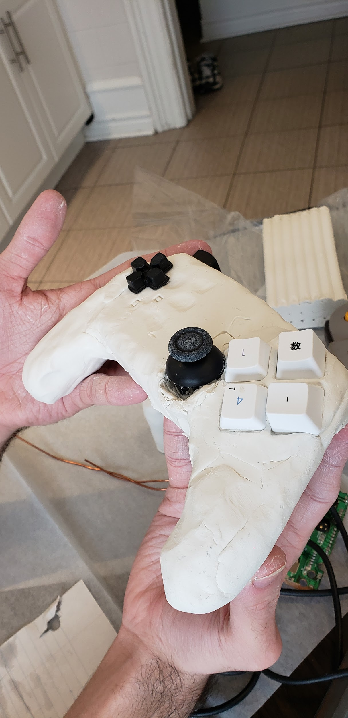

Fig. Clay Model

I kept intermittently working with the schematic and footprints. There were frequent changes to the pinouts that needed to be reflected in the schematic. There were also “Aha” moments regarding the custom parts in the schematic, specifically how the Teensy was represented. I found it convenient to use two different headers, one for the pins on the left side and one for the pins on the right side. I also experimented with more precise pad stacks, I found a Canadian manufacturer that had an open list of their drill sizes. I made some pad stacks using these other drill sizes but ultimately stuck to standard Olimex drills.

The clay model became the body for the first prototype, the 3D model was not yet ready for printing and it most closely represented what we wanted. I carved out pieces of the model to accommodate placing the components. I baked the clay at 275 degrees Fahrenheit for approximately one hour and 15 minutes.

Without a PCB, we needed to mount switches and other components to the clay somehow, perf boards were most optimal for our purposes, but not without flaws. The issue with using perf boards, is that mechanical key switches do not have a layout the easily fits on a perf board, and analog sticks also do not. The solution was to drill holes in the boards and angle the switches in a way that they would most easily fit into the perf board, which in turn caused them to not fit our desired layout. To mount the analog sticks, we soldered wires to each of their pins and glued them to the clay model.

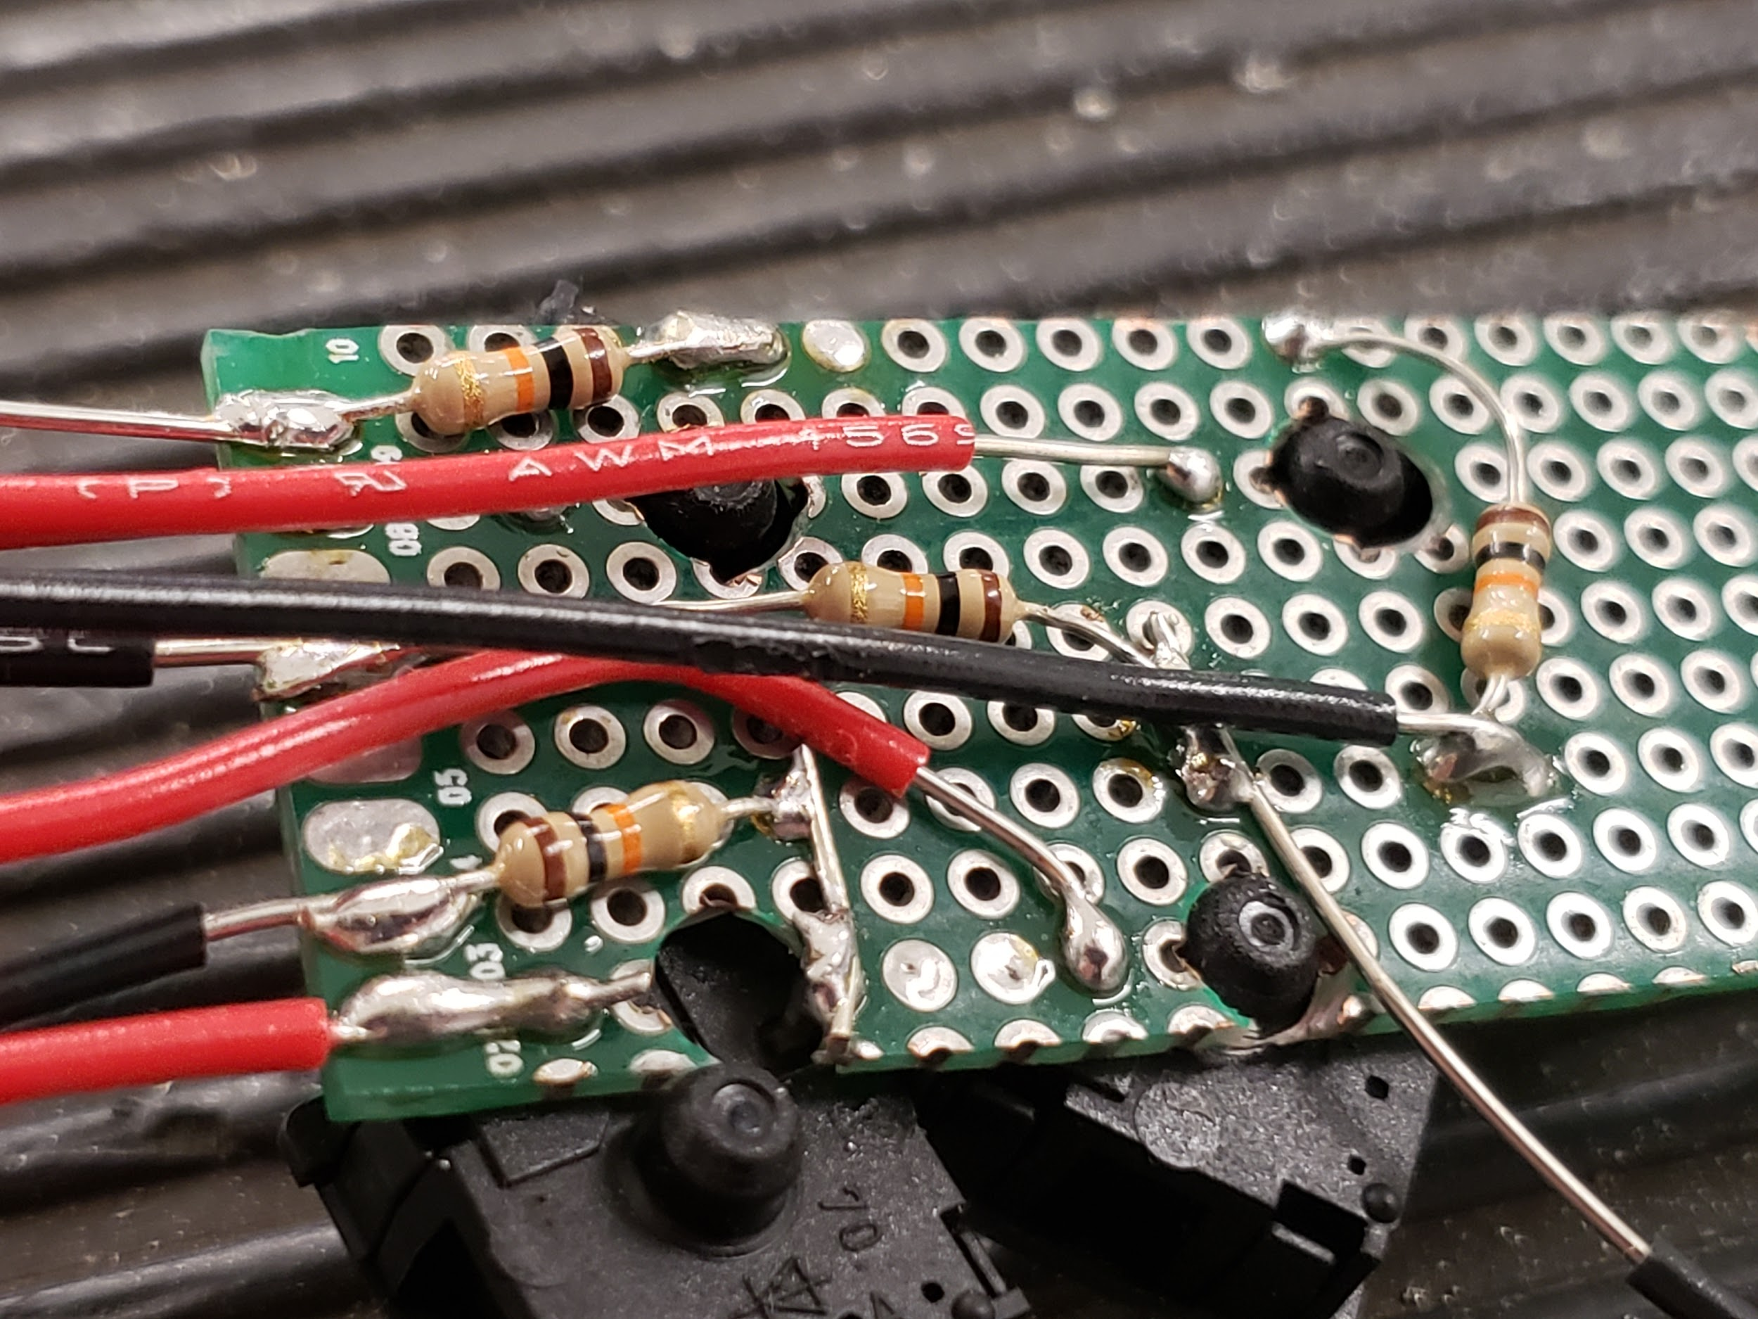

Fig. Soldered Keyswitchs and resistors

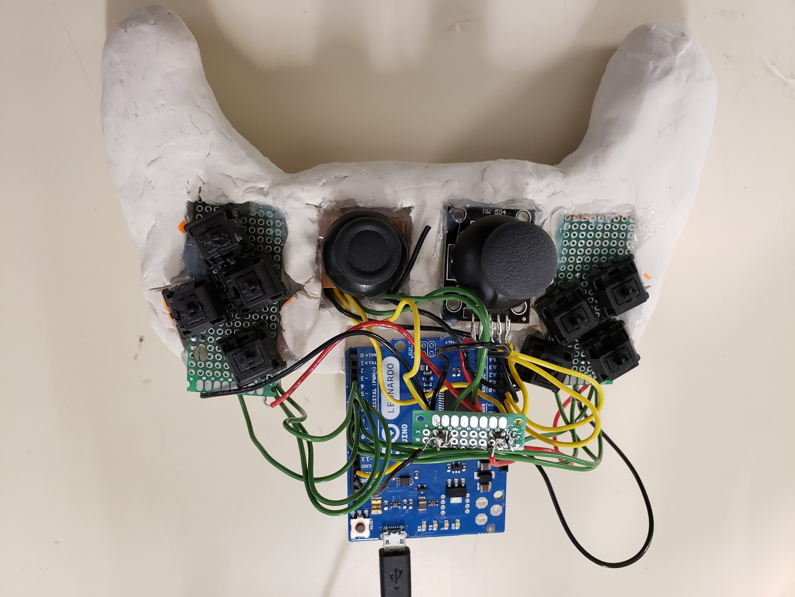

Fig. Completed clay prototype

The switches and resistors, once soldered to the perf boards, also needed an assortment of wires for power, ground and the wires for the Arduino. We also used another board to bridge all of the power pins, to plug just one pin into the Leo, and did the same for the ground pins. Finally we glued in the perf boards to the clay man and then wired the switches and analog sticks to the Leo for the sprint review just minutes later. The controller didn’t work during the review, a glance over the wiring afterwards revealed that the ground wire was connected to the power pin of the Leo. After correcting this problem the controller as expected.

## 3D Printed Prototype:

### James

James Now had to rewrite the code that was running on the Leonardo for the Teensy. The Teensy’s built in classes where very similar to the library used for the Leonardo. While converting the code for the hat switch James felt like there should be a way to be more efficient. He wrote a program in C99 that takes the current time, runs a function and gets the time again minus the first time to see the length of time it took to run that function. Because of the small amount of code being tested was the function containing the code had to be run 1 million times to read in the millisecond time. James put his code into the function and got a number. This number however didn’t mean much because dealing with such small amount of time any outside variable could be influencing this value. (running the same code again would result in close but different length).

To mitigate this and to get the highest confidence interval, James took the length testing code and ran it through a function that would run the code 100 000 times and take the average of all the runs. James’ new code was an average of 0.1 divided by 1 million milliseconds faster. He had changed it from an 8 long IF-else chain with 4 checks each down to a 3 long if- else chain with 1 check each that performs a linear equation.

Fig. comparisons of code time lengths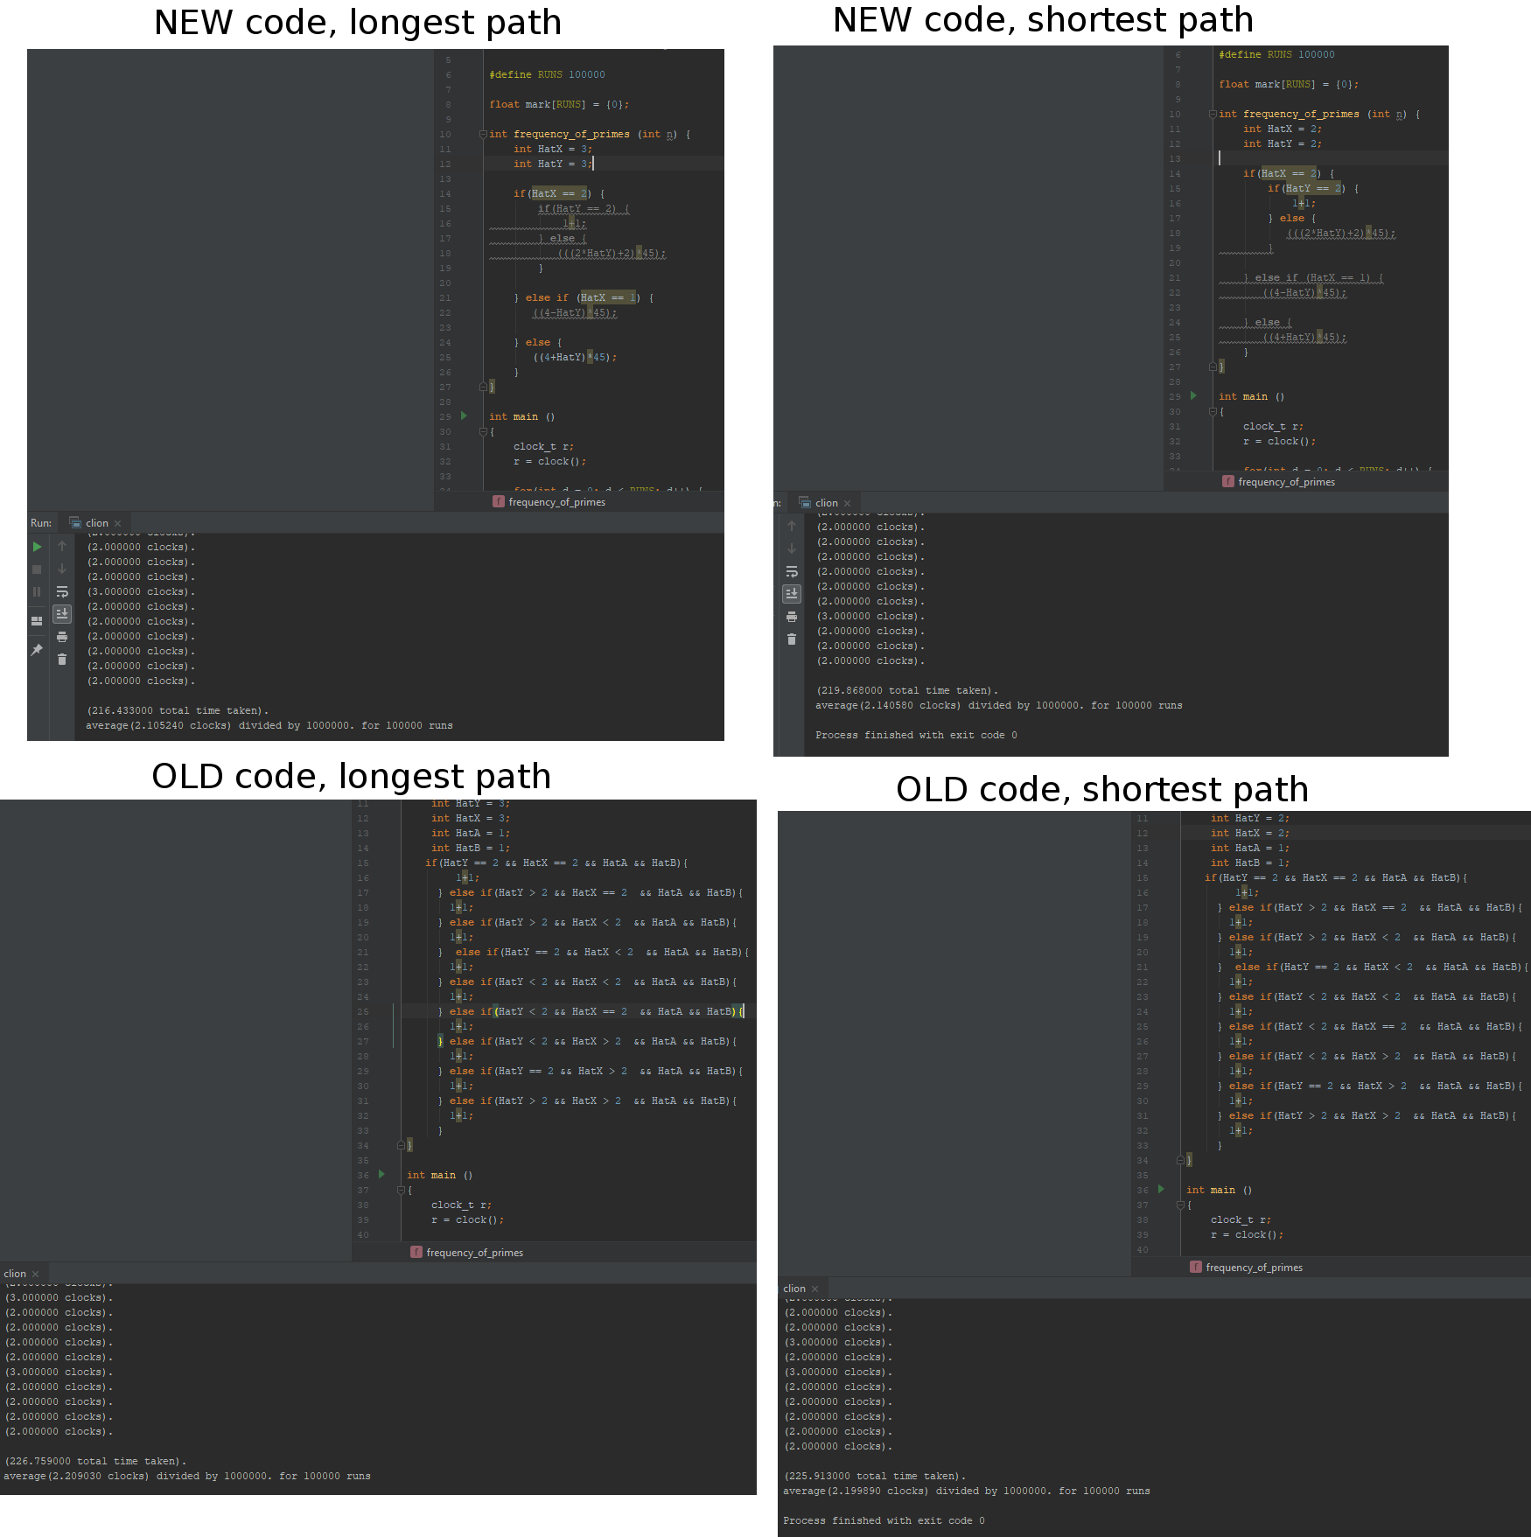

An minor Issue that caused james a lot of time is figuring out which button windows see correspond to what button place. Because we want our controller to be able to interact with applications designed for controllers, James needed to find the corresponding buttons. The Windows device manager only lists buttons 1 through 32, other controller testing apps do similar. A few apps that show it directly to Xbox buttons were not consistent with each other, making them useless. James found that there was very little information about this. What he did was borrow a controller from the Bluetooth robot group and press buttons to see the corresponding button. Using this information James then loaded up a game that had a settings page that should what buttons do what actions and tested it out. A few of the buttons where in the wrong position but He figured it out.

With the coding done james focused on putting the controller together.

Now that all the components were basically ready, we had to fit them into the 3d printed chassis. Paul wanted to use screws, they would be much more secure and removable. However Because the model was 3d printed it was not solid, for the screw to have any hold it would have to be in a wall of the filler material. This material is kinda thin. James believed that because of this screws would not hold for very long and a safer bet would be to use strong glue for this prototype, a final product would use screws.

We needed someway of mounting the pieces at a specific height to the model. Paul drifted towards screws again, but James wanted to find an alternative. James found a scrap piece of 2x4 wood, he liked working with wood and knew this would give the precision and sturdiness needed.

As a side note when James had come in this day, It looked like the lab had not been cleaned since before march break. Unable to work under these conditions he went into a fit of cleaning. Only wish there was a before picture

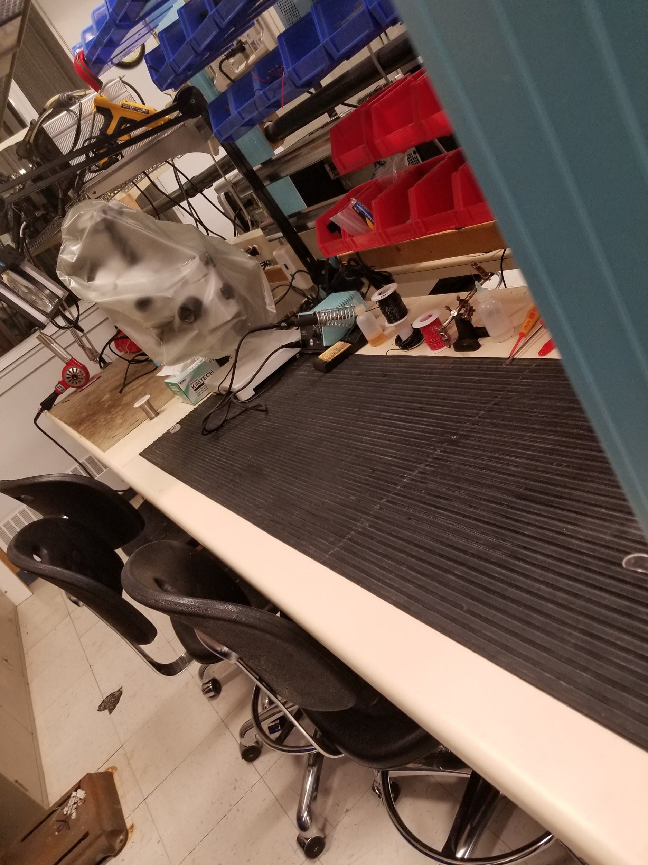

Fig. Cleaned lab

James and Nathan cut the piece of wood to fit within the 3d model, taking turns with a hacksaw in between recharging the battery for the power tools. The piece became a perfect fit. Next was cutting holes out of the wood that the components could rest into.

First we layout the parts, to find the optimal positioning before cutting. Because of the beefy size of the controller height and posistings was crucial to make the controller feel the best it can. When the whole team agreed on the positionings I measured and marked the depths and sizes on the wood to be cut

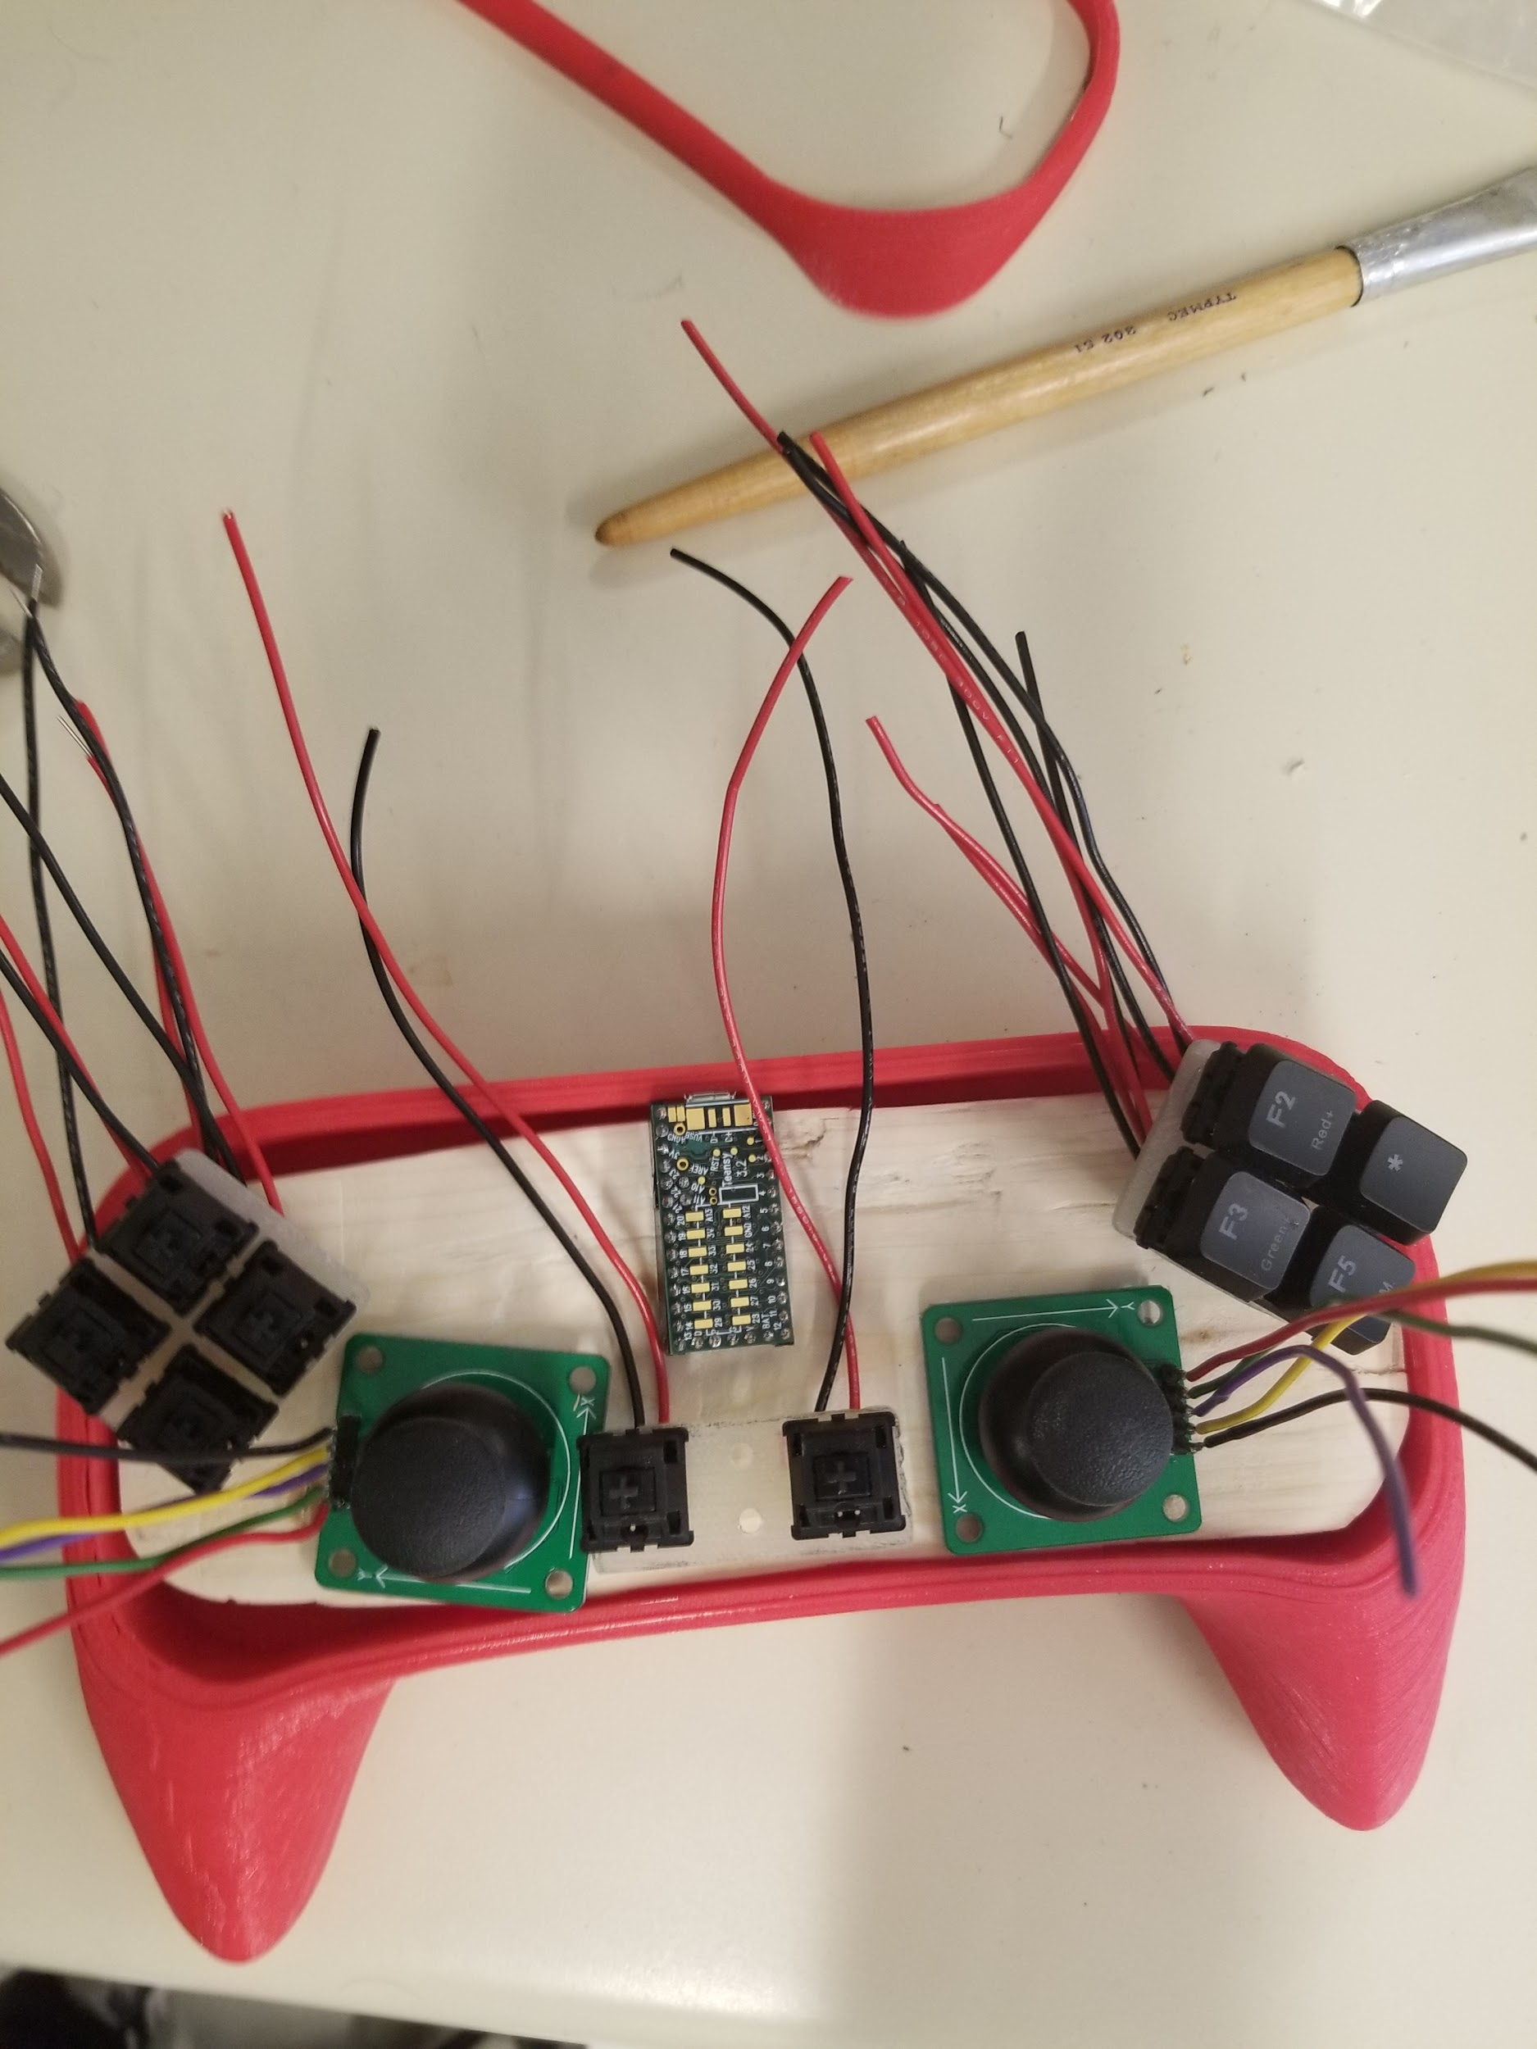

Fig. getting the layout

For the squares to hold the components, James dremeled the edges of the square to create clean sharp corners. Then with the idea from Ed, James used the drill to remove material at the furthest depth the hole was going. Then remove the piece that became separated and dremel sand the rough bottom. Holes and channels also needed to be added for routing wires. Below was the result of a really long day.

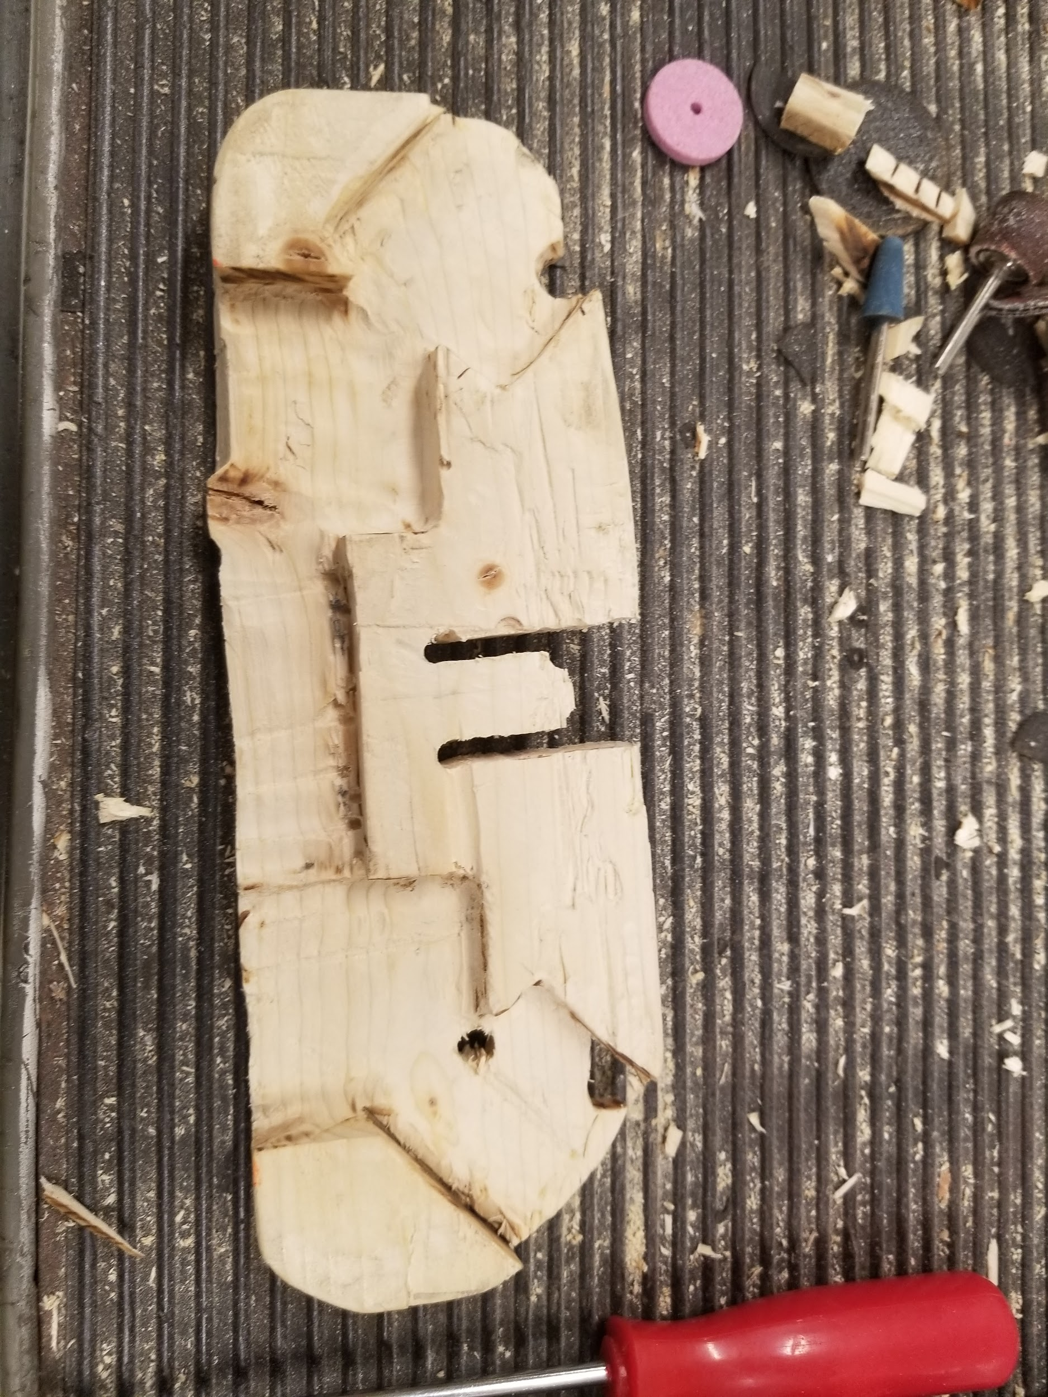

Fig. The wooden mounting board

Once all the parts fit at the right heights they where hot glued, first to get the exact positioning right and to double check before we clear gorilla guled the parts to the wood.The PCB of the right analog stick had to be cut because it was in the same space the board for the action buttons where going.

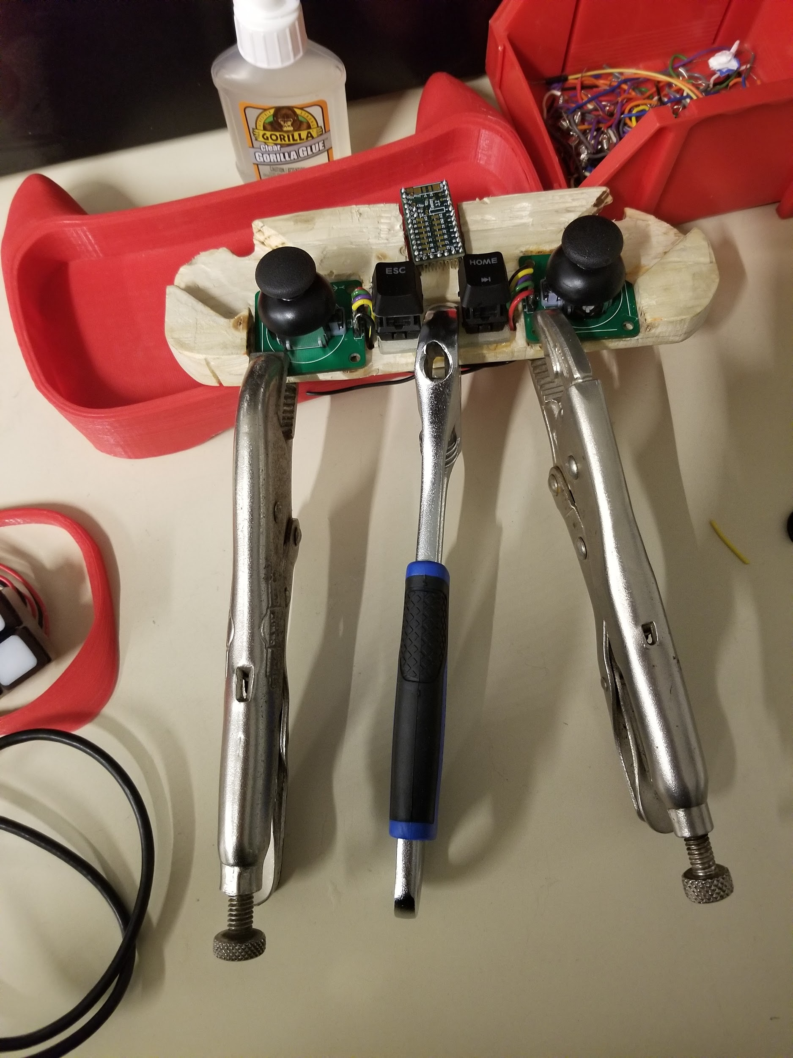

Fig. Glueing the components

With all the Parts in James started to wire the components to the teensy. While wiring it was important that from the back of the wood the height only extended 1 wirelength high. This was because that was the height accounted for, the components where already glued. It was not difficult but it cause the wiring to look unfavourable. It helped by using pinouts on the same side as the components to reduce overlap, but only one side was analog sensing pins. Doing this caused Paul’s schematic to be invalid again so James made sure to double and triple check each pin, documenting it, before putting the “wooden circuit board” into the chassis permanently.

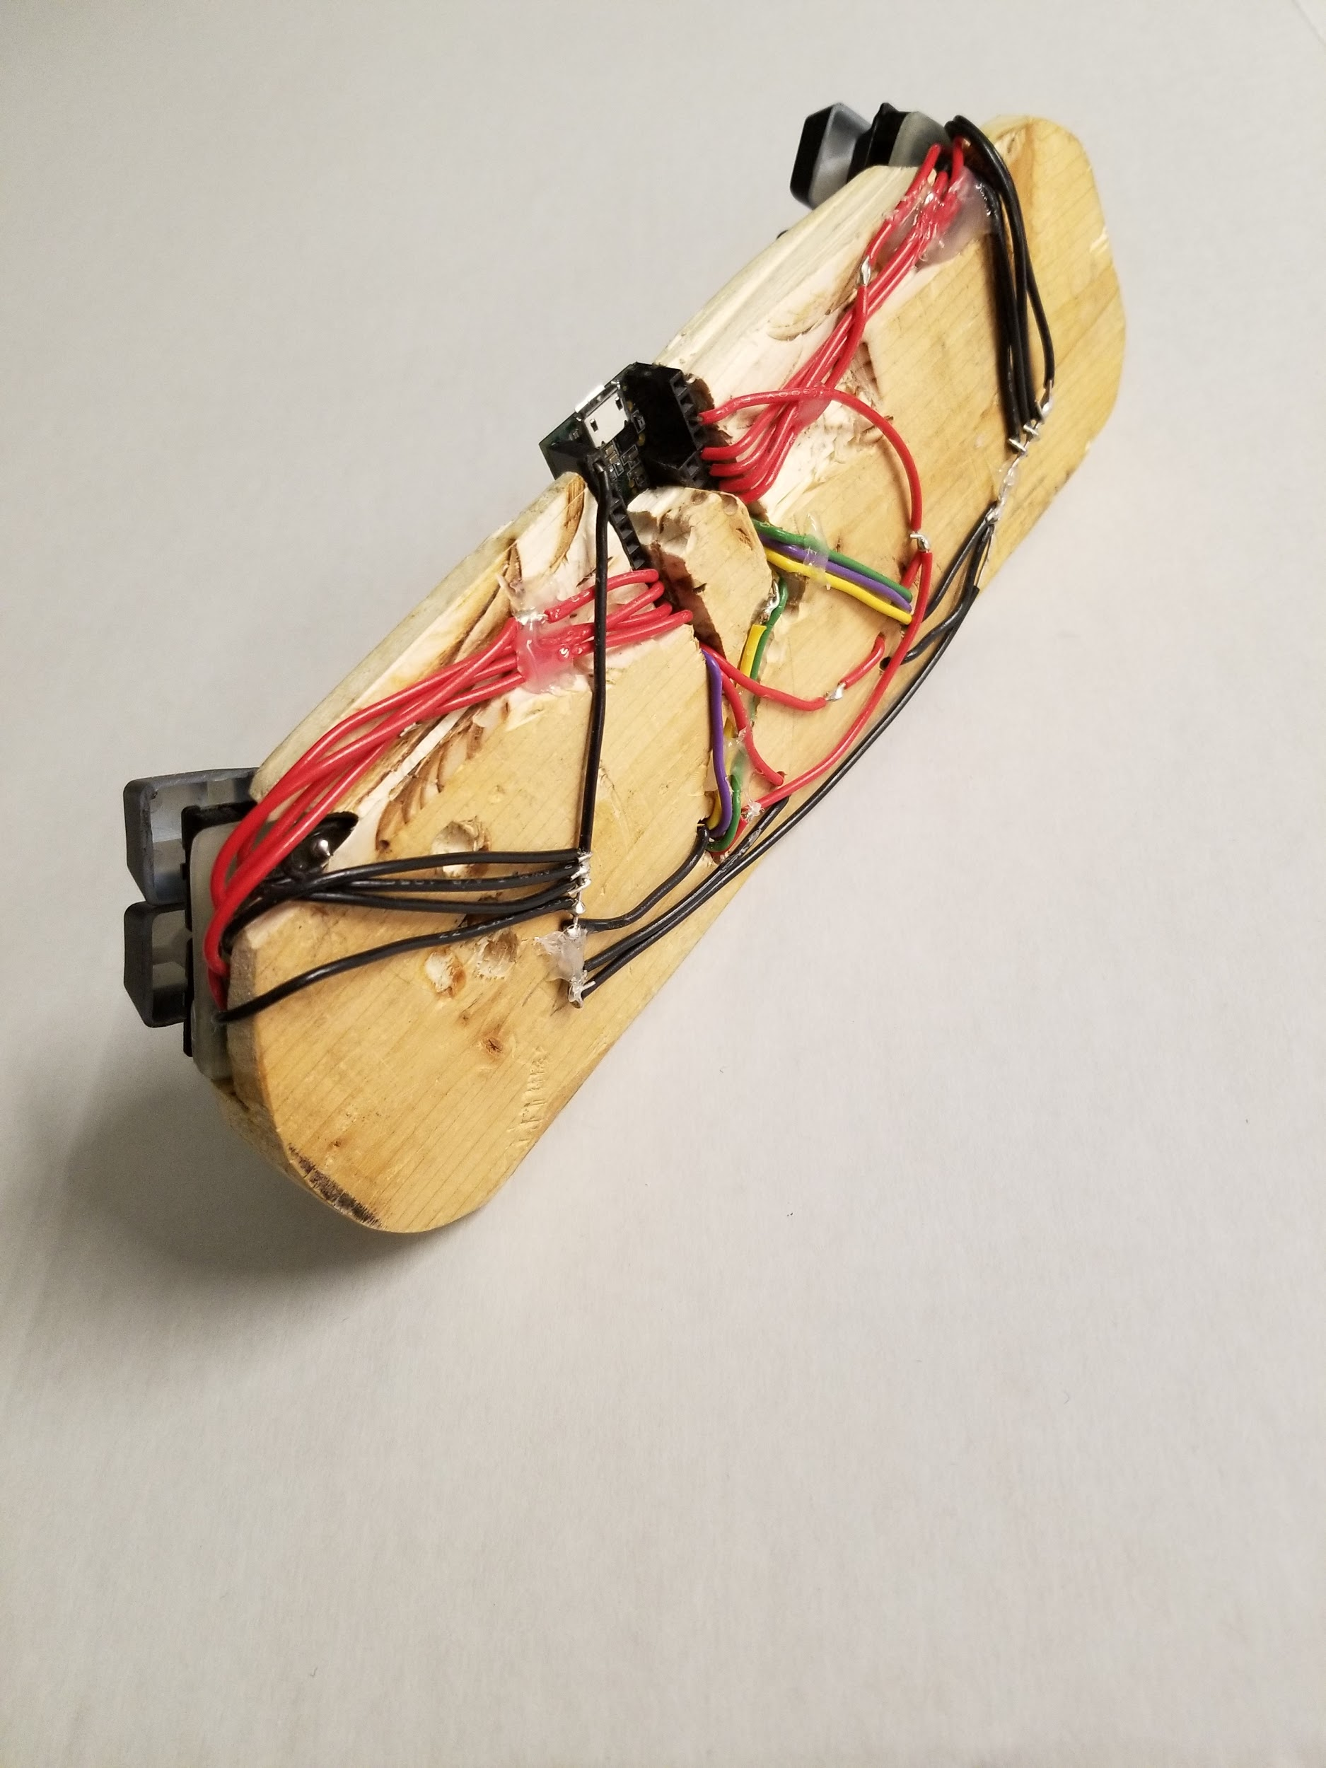

Fig. wired controller

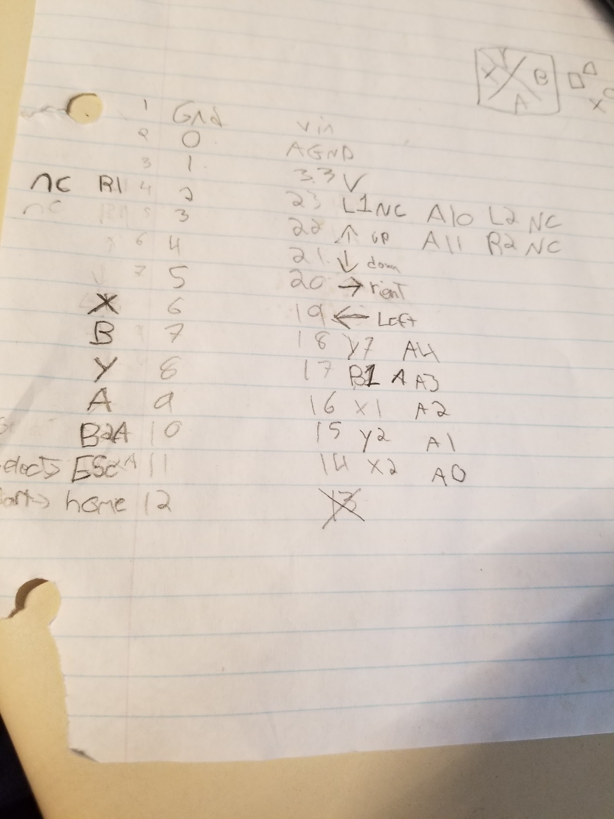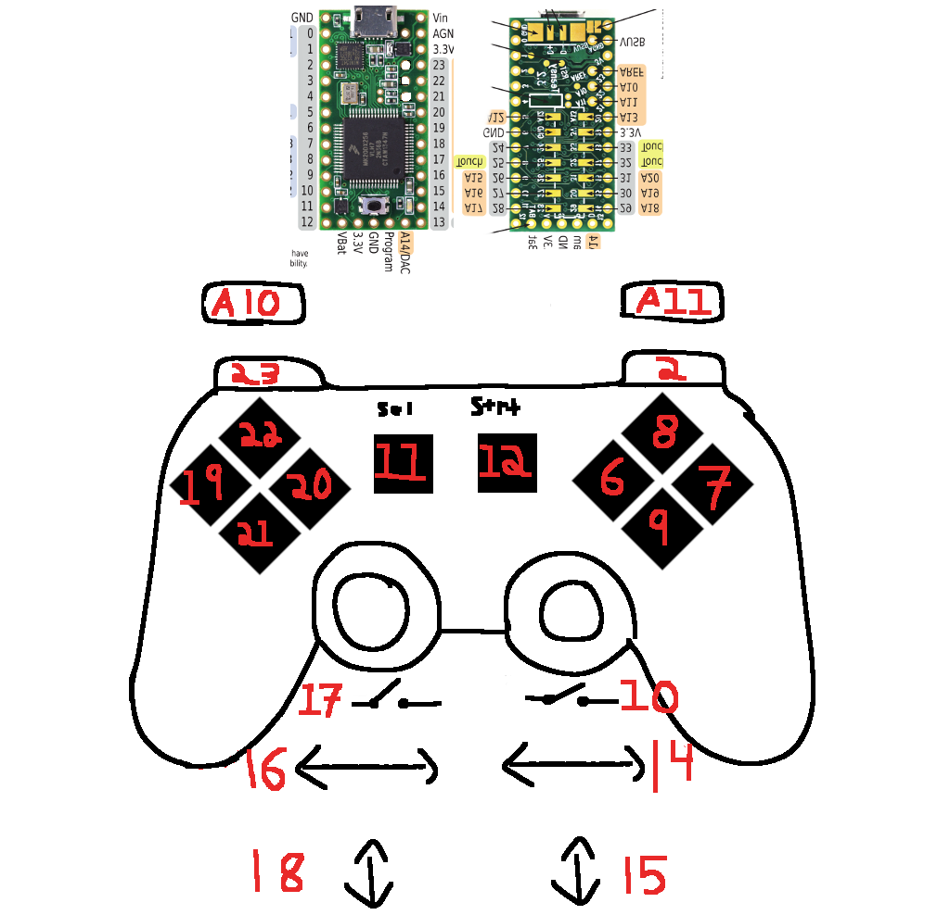

Fig. teensy pins with corresponding controller buttons

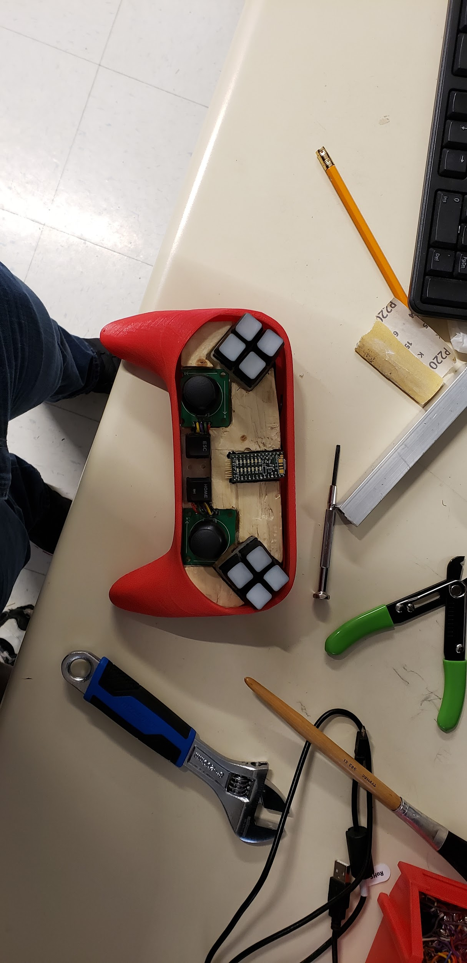

Fig. Testing the fit.

When the faceplate and riser Nathan had printing was done; James sanded the edges down because the print wasn’t perfect quality.

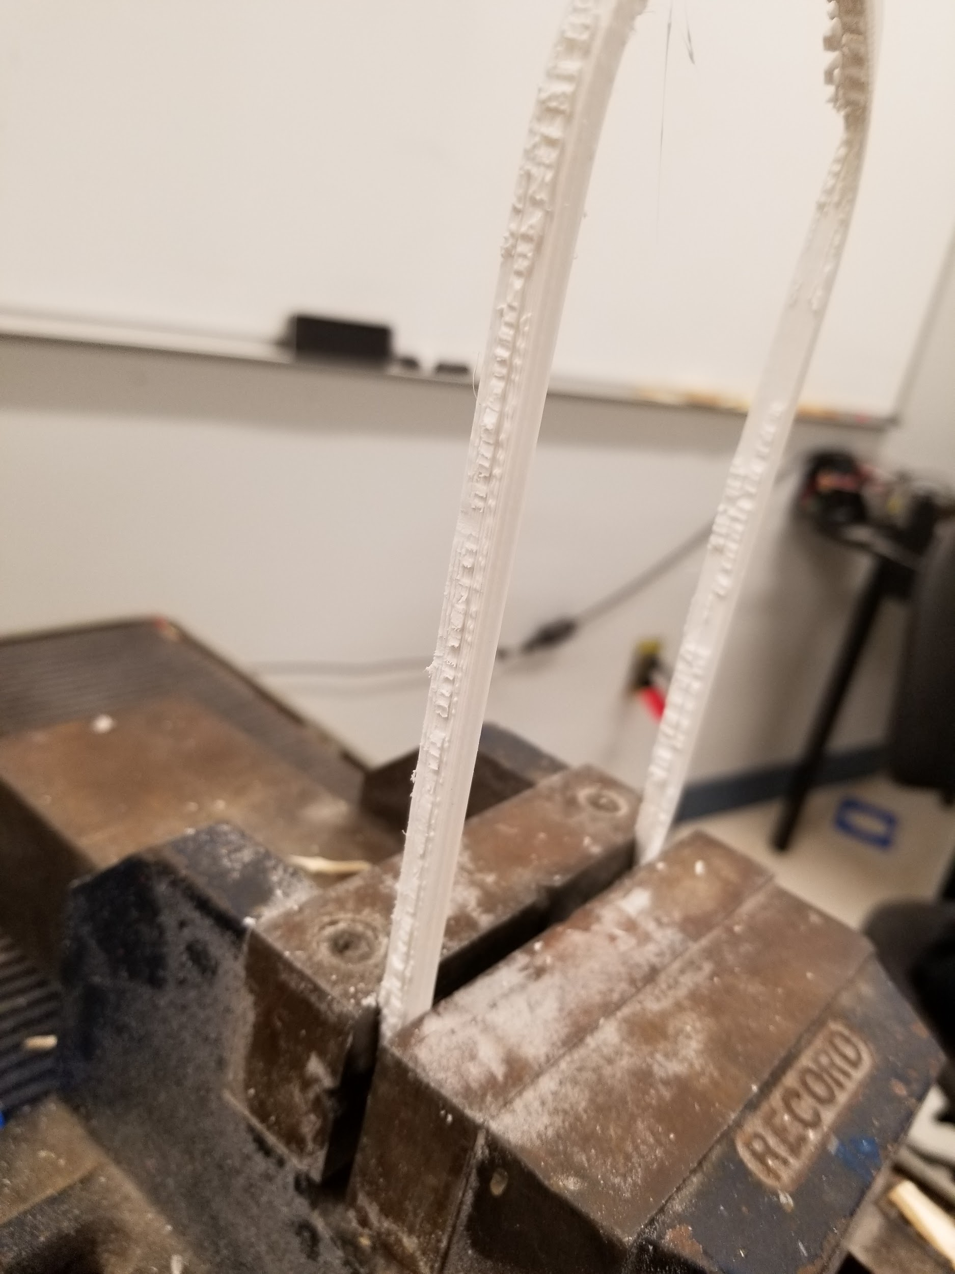

Fig. Riser for face plate

After Testing the the controller confirming everything was good, James hot glued the top on. He took the controller home to test it, as it was very late. When he got home he realised that the buttons where inverted to be on by default, and he forgot to uploaded his code to github.

The finalized design for the prototype looked like this

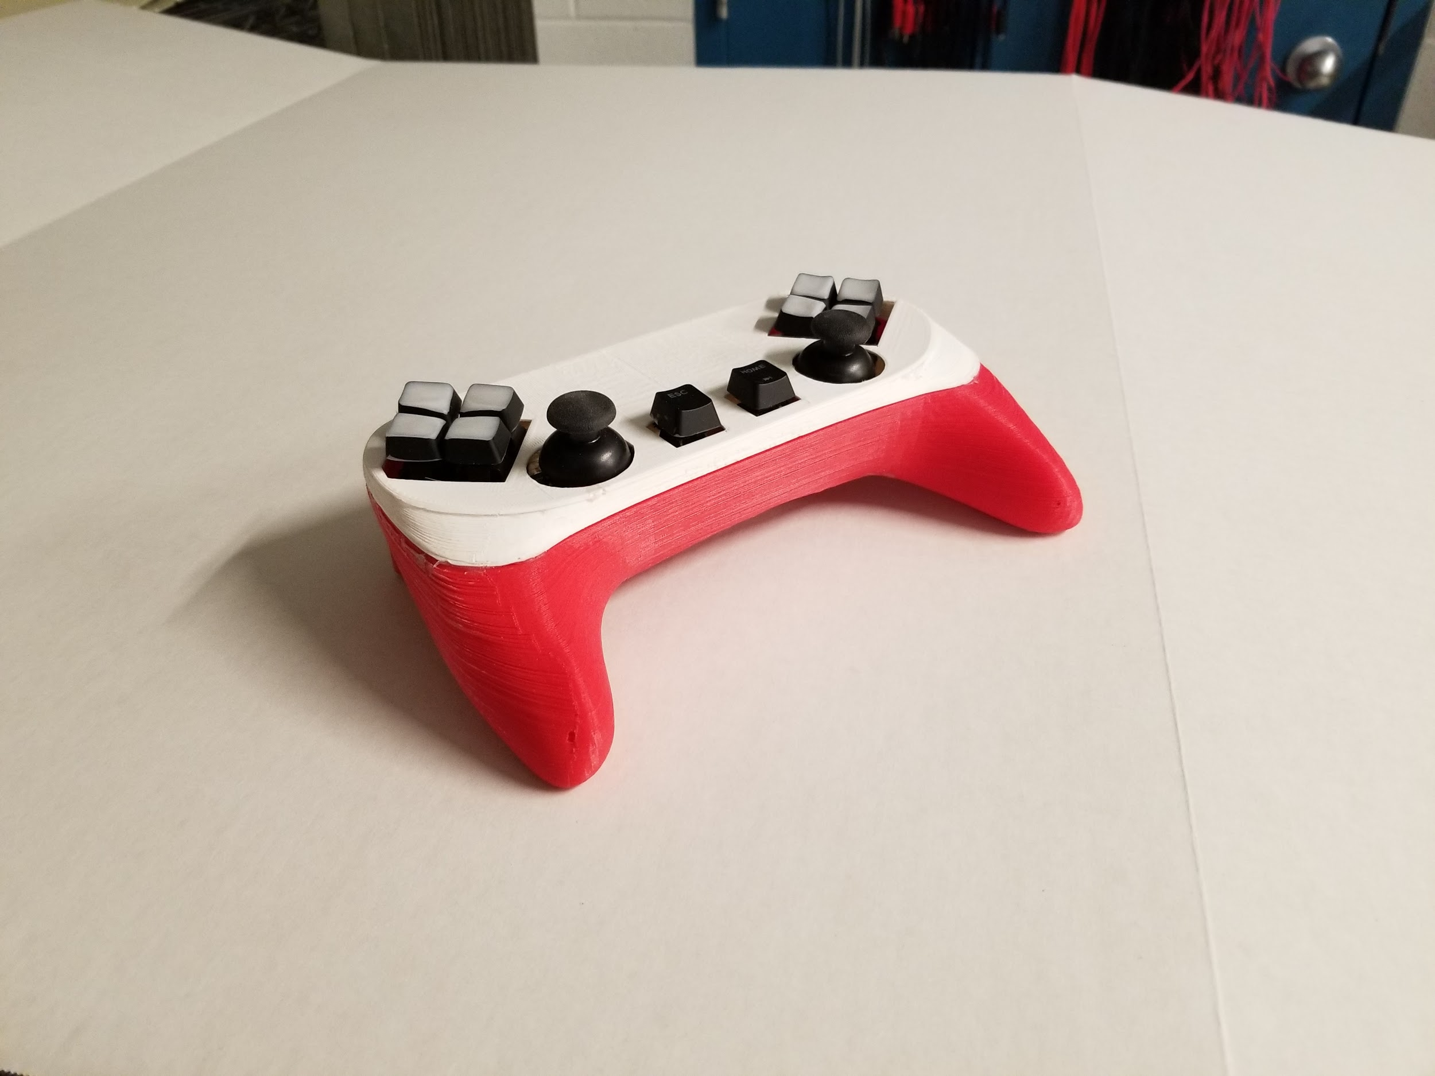

Fig. finalized controller

In preparation for the tech showcase the controller was confirmed to work and showed no errors so, James clear gorilla glued the faceplate on. As a last addition that added a very noticeable increase in quality, i smoothed the edges of the key caps. A quality of controllers is having to quickly switch between which button your pressing by sliding.

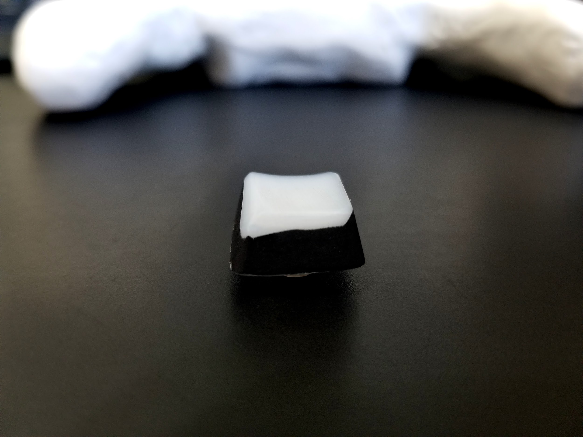

Fig. Rounded, shortened key cap

### 

### Paul

Building the second prototype was very similar to the first. This time, we had a 3D model printed and more space to work with. The first task was to find a better solution than perf boards to mount components. I desoldered more key switches from the scrap keyboard and we chose non-perforated, single sided, copper-clad laminate boards as our mount. I sanded all the copper from the board, and took measurements on them similar to the mounting on the perf boards, but with more freedom. I drilled out the holes for the switches and started doing test fits for the switches with keycaps on them. My placement of the switches with keycaps on them were too close.

I took the keycaps and dremeled the bottom half from them and then sanded the edges. I sanded them until I could press every key with the caps on them without any of them impeding the movement of another. I then dremeled out the D-PAD, ABXY and Start/Select sections and sanded those as well. I also took the keycaps and sanded off the top black layer of them revealing the translucent plastic underneath, we felt that it would look much less high quality if we had random keyboard lettering on all of the keycaps that didn’t correspond to anything that the button would actually be doing.

### Nathan

I started by importing the top down view of the clay model that we created to a canvas and sketching out the profile, at this time I planned to create the main body using usual extrude and modify options while only using the sculpt tools to create the grips. After making the body I moved on the sculpting the grip, both processes seemed to go well enough until I got to the point of realizing “How am I going to get both of these pieces together”. In hindsight I should have learned more about how to convert and blend sculpt-based and sketch-based forms but at the time I thought I should just cut my losses and try again with a different method.

For my second revision I went with an entirely sculpted form with no sketch whatsoever, this happened to become the final 3d printed product in the end. I started that same way I began with the last model by importing the top view of the clay model to a canvas, but this time I tried to sculpt out the top view. Due to the way that the sculpt view operates I tried to use the least amount of faces that I could without hindering the model since it would make the process much more reasonable to work with, for example; I could have a square face that has 2 intersections or one that has 50, If all I need to do make sure that face is flat then I don’t need more complicated than it needs to be. I only sculpted the right-hand side of the model, since the clay model was better distributed on the side, and then mirrored it to the left. After roughing out the basic shape of the body I began creating the grips by cutting away the faces at the front of the model and pulling the edges of the remaining faces down to a point where I stitched them back together. I didn’t have a good though process for how I was going to make the grips easier to work with since they were the most organic feature on the controller. I tried to reduce the amount of intersections in as many places as I could on the grips to make it less unwieldy to work with, but this proved difficult due to how I create the grips in the first place. I should have used an even number of faces when stitching the ends together (I ended up having an odd number), this left part of the grip that should have square faces, 4 edges, having 5 edges instead. I worked on trying to mitigate this as much as I could and still make the grip look nice and it worked out well. The model at this point had started to deviate from the original shape of the clay model due to the constraints I made on the sculpt in order to keep its form, this was one of the fundamental issues with using the sculpt environment for me. The sold sculpt body was done at this point with the only thing I had left to do was click finish form and then I’d be able to work on it more, but there was a problem with my sculpt preventing me from being able to convert it. The problems with the grip having 5 edges in some places also caused some faces to have slight openings and other faces going through the model. I striped back the problem areas one by one and manually remade the face clusters. After some minor cleanup I was able to finally finish the sculpt as move on to the other tasks.

The first thing I did was split the model into 2 pieces, the body where the components will go, and a cover. To do the split I created a face using the patch tools which intersected the model close to the top. Then I tried to hollow out both pieces. The cover was quite easy to hollow, I was able to get a reasonable wall thickness since it had simple geometry. The body on the other hand was not easy to hollow, I was only able to get 1mm of wall thickness which was much too thin to work with and the only work around while still using the hollow tool would be to convert the model back into the sculpt environment and redo the grips. This was not in my best interest so I brainstormed with the rest of the group about how I should go about it logically and James suggested that I make a flat plane that sits on the bottom of the inside of the body and work from there, so I did. After creating the plane, I boundary filled all the area under the plane and then made a sketch on the plane which I used to create a suitable wall thickness for the inside of the body. I keep consistency with the model I created a custom hollow for the cover to match the body better. I added a guide rail around the midpoint on the rim of the body and the underside of the cover so both pieces could “snap” together when 3d printed. Since at this time we didn’t have a final layout for the analog joysticks or key switches I cut the top face off the cover which I would redo later. At this point I consider this version of the controller done and ready to be printed.

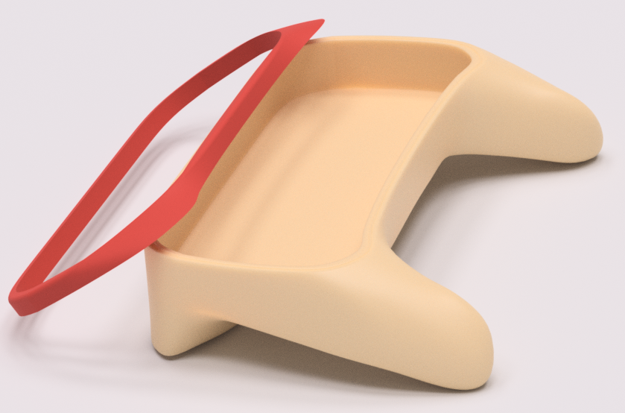

I 3d printed the cover of the controller firstly since it was fairly small compared to the rest of the model and gave me a good visual scale to see if I needed to make anything bigger or smaller before printing the main body. The body itself was difficult to print to say the least. Due to the nature of the body with its many curves and edges there was no way to print to all in one piece unless I used supports for it. I used Autodesk meshmixer an add on software that can auto generate supports for 3d printing. The first time I attempted to print the body there were many issues that caused it to be a failure. There were way too many supports, I didn’t print the model on a raft, and I didn’t use a enough hairspray to keep the model from rising.

# 

I redid the supports to be thicker with less supports overall and made sure to add a raft under the model as well as use a proper amount of hairspray. This even brought the total print time down from 36 hours to 34 (not much but at least it’s something). This print was successful with minor issues (the front left side of the raft raised slightly off the print board) now I had to remove the raft and the supports. The raft was easy to get off while the supports were a pain especially on and around the grips. It took a few hours to clean up at smooth out the bottom of the body with a Dremel and some fine sandpaper + sanding blocks.

# 

It was around this time that I had started working on a beta version of the controller model, but due to lack of time it was never finished.

## Remaining Work

### James

With no more work to be done on the controller James focused on cleaning up the GitHub and getting all the files that were shared though our discord server to each other.

### Paul

I moved on to finishing up the schematic and footprints. First I wanted to move past the roadblock that was not being able to make an analog stick footprint reliably. I decided to search for other generic analog sticks in hopes to find a datasheet with useful information. Quickly I was able to find a datasheet for an analog stick made by ALPS[27], it contained all the required pin sizes and measurements, and is made by a company with a strong reputation in similar markets.

Next I had to finish up the schematic, I got the final pinout from James and made a few tweaks to the Teensy parts. My attempt to generate the netlist for the BRD file succeeded with a few errors. The errors were about my pin numbers in my parts, orCAD requires pin numbers to be integers unlike my scheme of making the pin numbers the same as the pin name. Changing the pin numbers was the final step before creating the PCB design.

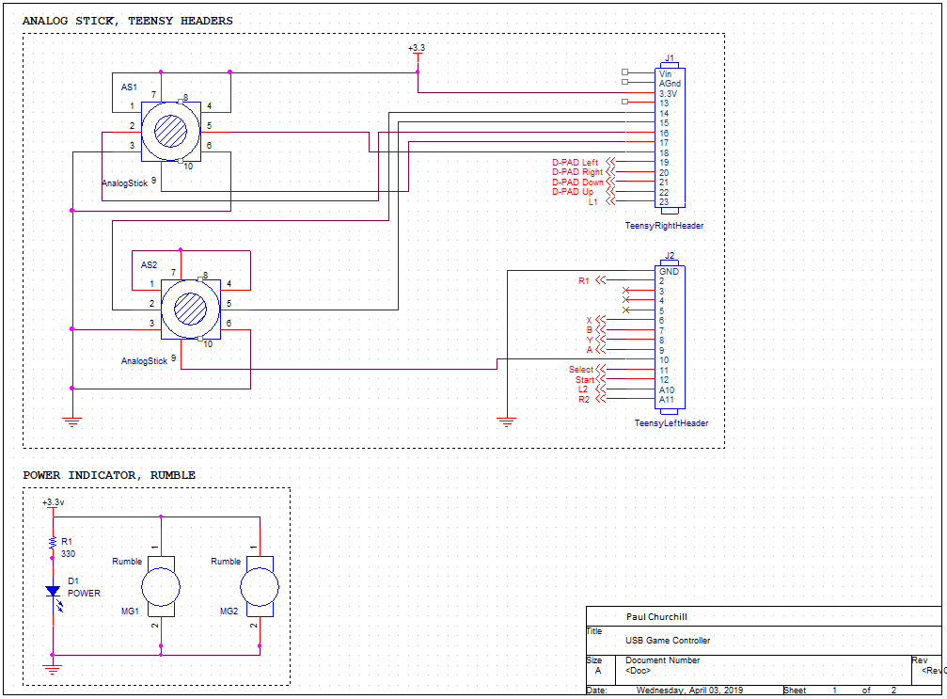

Fig. Analog stick to Teensy schematic

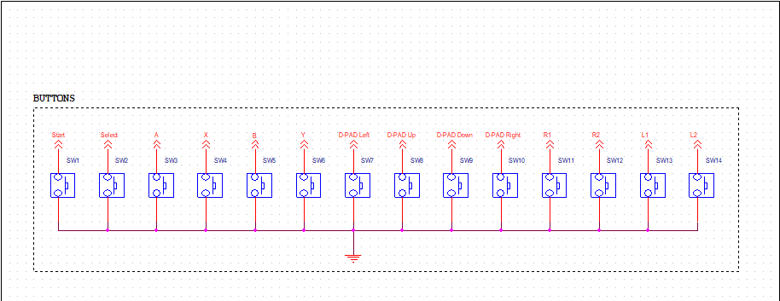

Fig. Button to Teensy Schematic

The PCB design presented a challenge in that I could be very precise with distances between components, but I had no way to test to practicality or functionality of my placements. My mindset when moving components around was to place key switches as though the keycaps on them would not be larger in width or height than the switch itself. I also had to refer to the Cadence forums to learn how to rotate components at a different angle than 90 degrees, and how to move more than one thing at once[28][29]. Placing the analog sticks was not precise and my only method to place them with certainty that they would not obstruct or be obstructed by any other component was to give them more space than I thought they could ever need. The L and R triggers were placed awkwardly at the top corners of the board. There is no way to to view or place components in 3D so placing them on the Z axis is not possible.

Routing the board was simple and problem free. I was mindful to use the smallest number of vias as possible. My board design at this point left minimal space between any given components with the exception of the analog sticks, but it was still larger than our second prototype. Apart from this problem and the odd L and R placements I was happy with what I had produced given we were running into very tight time restraints.

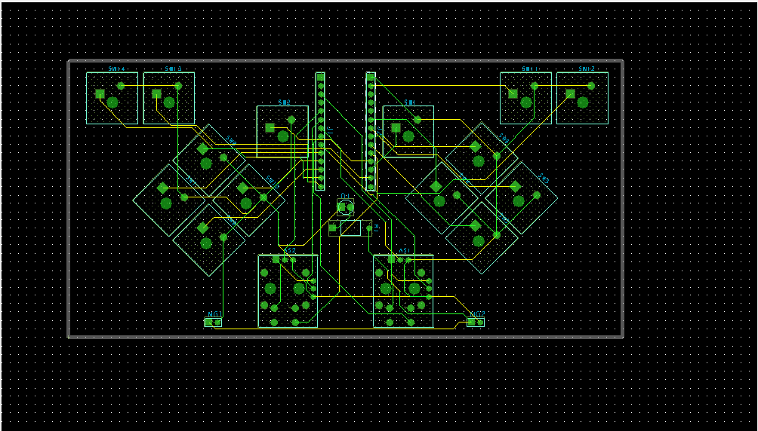

Fig. Final PCB

### Nathan

The final step was creating the final cover for the controller now that the final layout of the components was done. I did rough measurements of key points of where certain buttons were in relation to the side of the enclosure and created many trial and error 1mm thick covers to test what needed to be modified and what was good. In the end of merged the final layout for the cover with my previous cover model by extruding a sketch on top of the cover and using the cut tool.

# Conclusions

## Features:

The controller functions as a windows recognised generic controller device, able to be read by applications. The only functionality missing in this area is key-mapping software.

Our Controller has a 3d printed fully enclosed chassis. It is not the shape, nor the material we had planned from the start. Overall it has a feel that is not unpleasant, but is not a significant improvement over other available products.

The mounting board was hand carved from a piece of wood to secure all our components at the correct dimensions. As a time saver for a prototype this was very effective. A PCB would have been optimal.

For buttons we had hand smoothed, cherry mx black mechanical key switches arranged in a square pattern. This was equivalent to our goal, having them mounted on a PCB would be ideal, but the current state is up to par.

## Applications:

The applications of the controller we created would be the same as any other controller, with the exception that some PC games require specifically a xbox controller to be played with. Our controller does not emulate a Xbox controller, it emulates a generic game controller which not all games support.

## Limitations:

As with every project, time is the biggest limitation. Because we received the Teensy so late, and sculpting in 3D is no easy feat; we were roughly one week behind where we hoped to be. The time during March break helped us get back on track, but we still didn’t have enough time.

Because we did not want to sacrifice build quality anyware we could, we ended up sacrificing features to give us more time to perfect the features we did have. Features common among controller such as vibration, LED indicators, were sacrificed early on. The Idea of remappable buttons though a companion program was sacrificed for the same reasoning.

Critical controller features such as trigger, bumper, and home button(xbox) were sacrificed when we ran into issues with spacing. They were left out because we theorized that the time it would take to accommodate those buttons would prevent us from doing tasks that the product needed to be demonstrated as a functioning controller.

## Learned:

As a group we learned the importance of team communication and why scrum is a useful framework. It allows you to change your goal based on the work that your doing, which is incredibly handy.

During this project James learned how to manage a kanban chart though GitHub, The importance of having tasks sorted in a way that someone isn’t waiting to start doing work. When demonstrable progress is not shown at a sprint review it looks like your team hasn’t done much work.

Through research James learned a lot about controllers through the ages and design decisions they made. For example: the SNES controller featured circle handles, after getting a lot of feedback from the NES controller whose square edges would dig into users palms.[15] The NEO GEO pad’s D-pad (hat switch) was mechanical.[16]

With the help of Autodesk's youtube page as well as a plethora of other community made tips and tricks I (Nathan) was able to learn a lot more about the inner workings of fusion 360. I’m now knowledgeable about what every tool does in each environment as well as their best use case [19]. I learned how the sculpt environment functions and how to be efficient while using it [25], [22], [21], [20], [18], [17]. I learned about the patch environment and it’s many very useful applications that it has [23], as well as 3d sketchings techniques [24]. The use of a 3d printer for a complicated model required me to use Autodesk’s meshmixer tool to modify the model into more of a print friendly process as well as add supports. I leaned somewhat though trial and error the best options for the best 3d prints while keeping the time it takes for the print to finish within a reasonable time frame.

I (Paul) did not require much new technical knowledge to complete any tasks. What I learned was the benefits of project planning, proper communication among team members and the importance of documentation. Other things I learned include the requirements for parts and their pins in schematic capture and and how to speed up the PCB design process through moving multiple components and having more control over placing components.

## The Future:

The future for this project would be to create another prototype that has the features in our goal that our current prototype is missing (wooden chassis based on clay sculpture, buttons, remappable outputs).

From there the steps would be to produce multiple controllers, with the case being CNC’d and a manufactured PCB producing a controller would only take the time of soldering, smoothing the CNC’d wood, and securing the parts together.

This project seems like it would be a perfect case to go on a website like Kickstarter or Indiegogo. Early on we had a team meeting about this. We decided that though good things have came out of crowdfunding websites, the majority of projects are scams or do not fulfill their promises. If we wanted this to be a serious product we would not put it on kickstarter because even though it would give us a large head start, it would also come with the reputation of kickstarter.

Instead we proposed the plan that we would start by asking local game stores (locally owned game stores) if they would be willing to sell our product. We would have to convince them that our product would we worth their time. If there was a demand/interest among customers for our controller we would try to expand, get our product into more stores, or maybe set up exclusivity deals.

Alternatively, the DIY community would surely appreciate the effort put in to make this controller, considering that there are very few projects like it.

## Tech Showcase:

At the tech showcase, we had both of our prototypes to show, and let people use. This was a really good way of getting a lot of input on our designs.

Through the tech showcase there were people with all different hand sizes, including a few small children and a few older people. We were not surprised to find that among all the people what held our controller they all had very similar responses.

The very immediate response when first picking up the controller was to put their fingers on the trigger buttons. They would look at the top of the controller and we would have to explain that we ran into a spacing issue. The next thing they did was move the analogs and press some of the buttons. Many people got very excited after pressing a button. The rest of the people who tried the buttons also liked them and did agree that it felt good. This gave us a lot of pride and excitement; that our idea of creating something that felt good was shared with a lot of the people who tried it.

Another Idea was with everyone who held the controller, and that was the 3d model was a bit too large, awkward to hold in the hand at times. This is when we would explain our clay model. Not everyone held the clay model, but the people who did agreed that the components in our prototype in the shape of the clay model would be much better.

Overall, presenting at the tech showcase went very well, Seeing people enjoy your creation is amazing. All of the criticisms we received, we ourselves had also noted it, but the fact that the feedback was so unanimous means that these things are really important if we plan to move forward.

# References

[1] Dave Nunez (2015). DIY USB controller using the Teensy. <https://www.youtube.com/watch?v=k2AFp9BOJg8>

[2] NextFab (). Making a game controller (using a Leonardo) <https://www.instructables.com/id/Making-a-USB-Game-Controller/>

[3] Travers Henry() Let's make a game controller (using the teensy) <https://www.instructables.com/id/Lets-make-a-game-controller/>

[4]Tomash (2017) Music mixers/machines (Using Teensy)

<http://tomashg.com/>

[5] sparkfun () pro micro

<https://www.sparkfun.com/products/12640>

[6] Jcweinberg (2013) controller to NES <https://forum.pjrc.com/threads/16848-Teensy3-to-Nintendo-Entertainment-System>

[7] Marcredi (2015) Flight sim cockpit (Using Teensy)

<http://nicolasmontarnal-en.blogspot.com/>

[8] Alpinedelta () creating a 60% keyboard with Teensy

<https://www.instructables.com/id/Make-Any-Vintage-Keyboard-Work-With-a-Modern-PC/>

[9] pjrc () the creators of teensy

<https://www.pjrc.com/teensy/>

[10] James Poirier (2019) original (not used) Teensy code <https://github.com/srjamesjr/CoNtrOleR/blob/master/Sketch/controller_sketch.ino>

[11] MatthewH (2017) Leonard as game controller

<https://www.instructables.com/id/Arduino-LeonardoMicro-as-Game-ControllerJoystick/>

[12]MatthewH (2017) Arduino joystick library <https://github.com/MHeironimus/ArduinoJoystickLibrary/tree/version-1.0>

[13]]MatthewH (2017) Arduino joystick library [LICENSE](https://github.com/MHeironimus/ArduinoJoystickLibrary/blob/version-1.0/LICENSE) <https://github.com/MHeironimus/ArduinoJoystickLibrary/blob/version-1.0/LICENSE>

[14]MatthewH (2018) Arduino joystick library V2 <https://github.com/MHeironimus/ArduinoJoystickLibrary>

[15] Foster Kamer (2012) The nintendo controller <https://www.complex.com/pop-culture/2012/11/nintendo-controllers-evolution-gamepads/nes-advantage>

[16] Satoshi Matrix (2013) The controller Chronicles: Neo Geo <https://www.youtube.com/watch?v=e816PhjcsAA>

[17] Autodesk Fusion 360 (2016) Webinar - Sculpting Basics (& More)

<https://www.youtube.com/watch?v=_MPnyFKKH8k>

[18] Autodesk Fusion 360 (2017) Quick Tip: Sculpting Tricks

<https://www.youtube.com/watch?v=EO_2QsekC8g>

[19] Autodesk Fusion 360 (2016) QUICK TIP: Join THEN Build

<https://www.youtube.com/watch?v=Jerea21nZQs>

[20] Autodesk Fusion 360 (2016) QUICK TIP: Object Snap in Sculpt

<https://www.youtube.com/watch?v=gAmmN-6jR34>

[21] Autodesk Fusion 360 (2018) Create and Modify in the Sculpt Workspace

<https://www.youtube.com/watch?v=3Oa1A4aSoWk>

[22] Autodesk Fusion 360 (2015) Shape it Up! Lean How to Create a Solid Form Model

<https://www.youtube.com/watch?v=VPpbaKqTS2c>

[23] Autodesk Fusion 360 (2016) How to Sculpt the New Fusion 360 Logo

<https://www.youtube.com/watch?v=XD7HBFlIFMM>

[24] Autodesk Fusion 360 (2015) Webinar Advanced Sketching

<https://www.youtube.com/watch?v=Dfxm8irfEhc>

[25] Autodesk Fusion 360 (2016) Surface Modeling with Fusion 360

<https://www.youtube.com/watch?v=NypRE2aFhh4>

[26] Cherry MX Keyswitch Datasheet

<https://datasheet.octopart.com/MX1A-11NW-Cherry-datasheet-34676.pdf>

[27] ALPS Analog Stick

<https://www.alps.com/prod/info/E/HTML/MultiControl/Potentiometer/RKJXK/RKJXV1224005.html>

[28] Moving multiple components at once in PCB Editor

<https://community.cadence.com/cadence_technology_forums/f/pcb-design/23191/moving-multiple-components-at-once>

[29] Rotating components at different angles in PCB Editor

<https://community.cadence.com/cadence_technology_forums/f/pcb-design/11764/rotating-parts-in-pcb-editor>

# Appendices

All of our files are stored on GitHub (<https://github.com/srjamesjr/CoNtrOleR>) under apportally

named folders:

Daily journals:<https://github.com/srjamesjr/CoNtrOleR/tree/master/Daily%20Journals>

Project Management files:<https://github.com/srjamesjr/CoNtrOleR/tree/master/Project%20Management>

Nathans 3D modeling files: <https://github.com/srjamesjr/CoNtrOleR/tree/master/CADD%20model>

Pauls Schematic and PCB files: <https://github.com/srjamesjr/CoNtrOleR/tree/master/CADD%20schematics>

James code:<https://github.com/srjamesjr/CoNtrOleR/tree/master/C_efficiency_tester> **and** <https://github.com/srjamesjr/CoNtrOleR/tree/master/Sketch>

## Component Specifications:

**The prototype we finished with uses:**

MicroController: The Teensy 3.2 (<https://www.pjrc.com/store/teensy32.html>)

Analog sticks(2x): Metal analog stick (<https://www.aliexpress.com/item/2Pcs-For-XBOX-360-3D-Joysticks-Metal-Analog-Sticks-3D-Analog-Joystick-for-PS2-Controller-Repair/32830004134.html>)

buttons(10x): salvaged Cherry MX black mechanical key switches (<https://mechanicalkeyboards.com/shop/index.php?l=product_list&c=13>)

Chassis: The Chassis was 3D printed from PLA plastic on a Makerbot replicator from the designs of Nathan

Circuit board: (we didn’t have a real circuit board) The board was made from hand shaped wood and wires was used to connect the components.

**The clay prototype used:**

MicroController: An Arduino Leonardo (<https://store.arduino.cc/usa/leonardo>)

Analog sticks(2x):These were not the exact sticks used, the original ones we had use swiftly broke and we used this as a replacement <https://circuit.rocks/joystick-analog-arduino.html>

buttons(8x):salvaged Cherry MX black mechanical key switches (2mm actuation distance, 60g actuation force)(<https://mechanicalkeyboards.com/shop/index.php?l=product_list&c=13>)

Chassis: Sculpey Polymer clay (<https://www.amazon.ca/Polyform-Sculpey-Original-4-Pound-White/dp/B003O2PGBE/ref=sr_1_24?hvadid=208343092292&hvdev=c&hvlocphy=9060777&hvnetw=g&hvpos=1t1&hvqmt=e&hvrand=5285286399262830661&hvtargid=kwd-301091551913&keywords=polymer+clay+sculpey&qid=1555089360&s=gateway&sr=8-24>)

Circuit board: Perforated board with custom holes drilled (on top of the holes that were already there).

Glamour shots

